25.6 Editors - Properties Editor - World Properties Tab
World Tab 2
World Edit Box 2
World Browser 2
World Edit Box 2
Fake User 2
New 2
Remove 2
Viewport Display - All Renderers 3
Color 3
Animate Property 3
Custom Properties Panel - All Renderers 3
Add 3
Edit 3
Remove 3
Surface Panel - Eevee and Cycles 3
Use Nodes 3
Color without nodes 4
Surface 4
Cycles - Preview Panel 4
Eevee and Cycles - Volume Panel 4
Eevee and Cycles - Mist Pass Panel 5
Start 5
Depth 5
Falloff 5
Cycles - Ambient Occlusion Panel 5
Enable 5
Factor 5
Distance 5
Cycles - Ray Visibility Panel 5
Camera 6
Diffuse 6
Glossy 6
Transmission 6
Volume Scatter 6
Cycles - Settings Panel 6
Surface 6
Sampling 6
Map Resolution 6
Max Bounces 6
Volume 7
Sampling 7
Interpolation 7
Homogeneous 7
Step Size 7

World Tab

The world tab provides you with world settings. Like Viewport Display color.
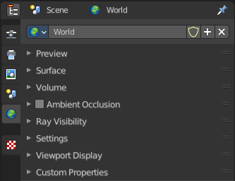
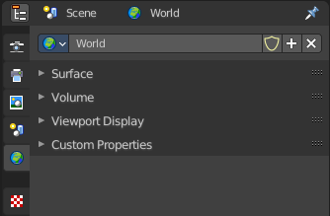
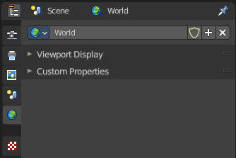

The content vary, dependent of the chosen renderer. From left to right: Eevee, OpenGL, Cycles.

World Edit Box
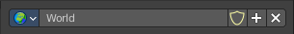
Here you can manage and change your world settings. There can be more than one World.

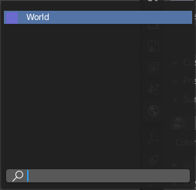
World Browser
Here you can see and choose your world files.

World Edit Box
Here you can see and change the name of the current world file.

Fake User
When enabled then this world file will be stored internally. And will remain in the scene.

New
Create a new world file.

Remove
Note that this just sets the World file inactive. It is still in the list. You can delete the world file when it has no user anymore by saving the scene, closing and reopening Bforartists.

Viewport Display - All Renderers

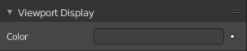
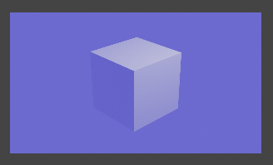
Color
The color that you can choose here is the background color for rendering the image.

Animate Property
This property can be animated. Activating this button sets a keyframe.

Custom Properties Panel - All Renderers

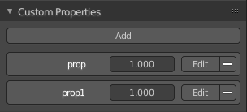
Here you can define custom properties that can be used for scripting.

Here you might also find custom properties from addons or scripts.

Add
Adds a new property.


Edit
A panel where you can adjust the settings for the custom property.

Remove
Removes the property.

Surface Panel - Eevee and Cycles

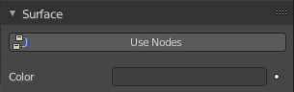
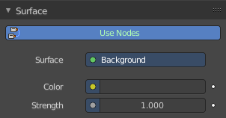
Use Nodes
Use Nodes or simple background color.
When you use Nodes then you will reveal further options.
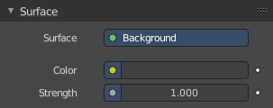
Note that Cycles misses the Use Nodes button once you have activated the nodes.

Color without nodes
The color that you can choose here is the background color for rendering the image.

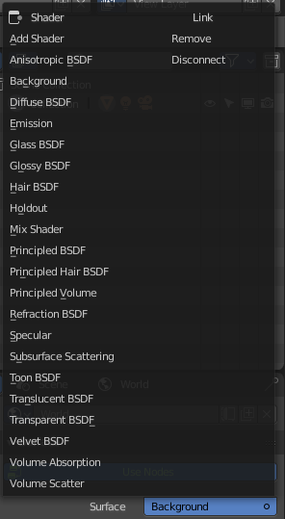
Surface
Here you can choose what shader you want to use for the background. Usually the Background shader. But you can use any shader in the list here too.
The options below changes dependent of the shader that you choose. They are explained in the shader editor chapter.
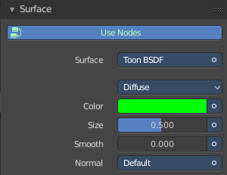
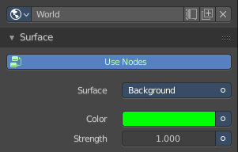

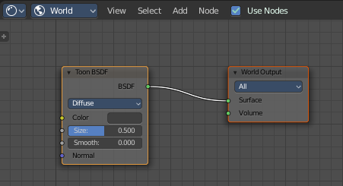

Cycles - Preview Panel
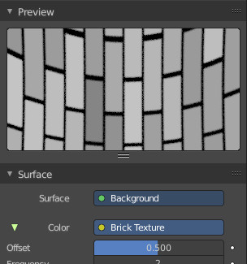
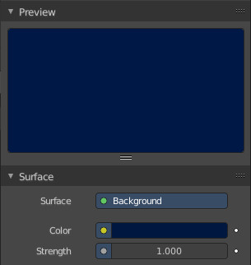
The Preview panel gives you a preview of the background color.

The color can also be an image. This depends of what you have chosen for the color method in the surface panel.

Eevee and Cycles - Volume Panel

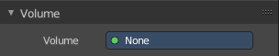
This panel just appears when you tick Use Nodes.

Volume rendering is a method to render light as it passes through a media within a 3D region. Here you can choose a shader for volume rendering.

Eevee and Cycles - Mist Pass Panel

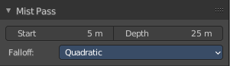
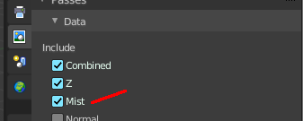
When you activate Mist in the View layers Tab Passes Panel, then the Mist Pass panel shows in the World tab.

Start
The starting distance of the mist, measured from the camera.

Depth
The distance over which the mist effect fades in.

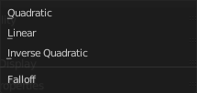
Falloff
The falloff progression of the mist.

Cycles - Ambient Occlusion Panel
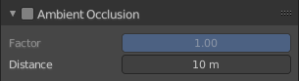
Ambient Occlusion is a method to self shadow surfaces in corners. The closer the faces to each other, the darker they get.

Enable
In the header is a checkbox to enable Ambient Occlusion.

Factor
The factor for ambient occlusion blending.

Distance
The maximum distance at which Ambient Occlusion gets calculated.

Cycles - Ray Visibility Panel

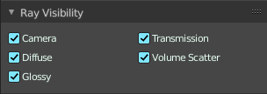
Here you can adjust the ray visibility.

Camera
Object Visibility for Camera rays.

Diffuse
Object Visibility for Diffuse Reflection rays.

Glossy
Object Visibility for Glossy Reflection rays.

Transmission
Object Visibility for Transmission rays.

Volume Scatter
Object Visibility for Volume Scatter rays.

Cycles - Settings Panel
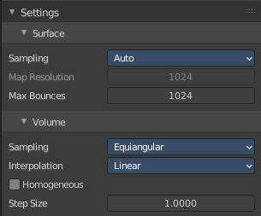

Surface

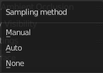
Sampling
Here you can choose the method for the surface sampling.

Map Resolution
When you choose sampling method manual, then you can adjust the map resolution here.

Max Bounces
Maximum number of bounces the background light will contribute to the render.

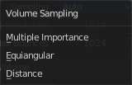
Volume

Sampling
Here you can choose the volume sampling method.

Interpolation
Here you can choose between cubic and linear interpolation.

Homogeneous
When using volume rendering, assume that the volume has the same density everywhere.

Step Size
Distance between volume shader samples when rendering the volume. Lower values increases accuracy and render time.

